Hi, I'm back. In my last article I said that I was going to talk about split brains in Agents. For this let’s use our old friend - in the AI era 4 years seems like 40 - Gemini. I used it in the last article, check it out if you need.
How we know Gemini shows, in a discovery-product query, the answers in the body of the chat but the gemini shopping bar too. I used comparison queries to do the examples and if you remember I got this answer:

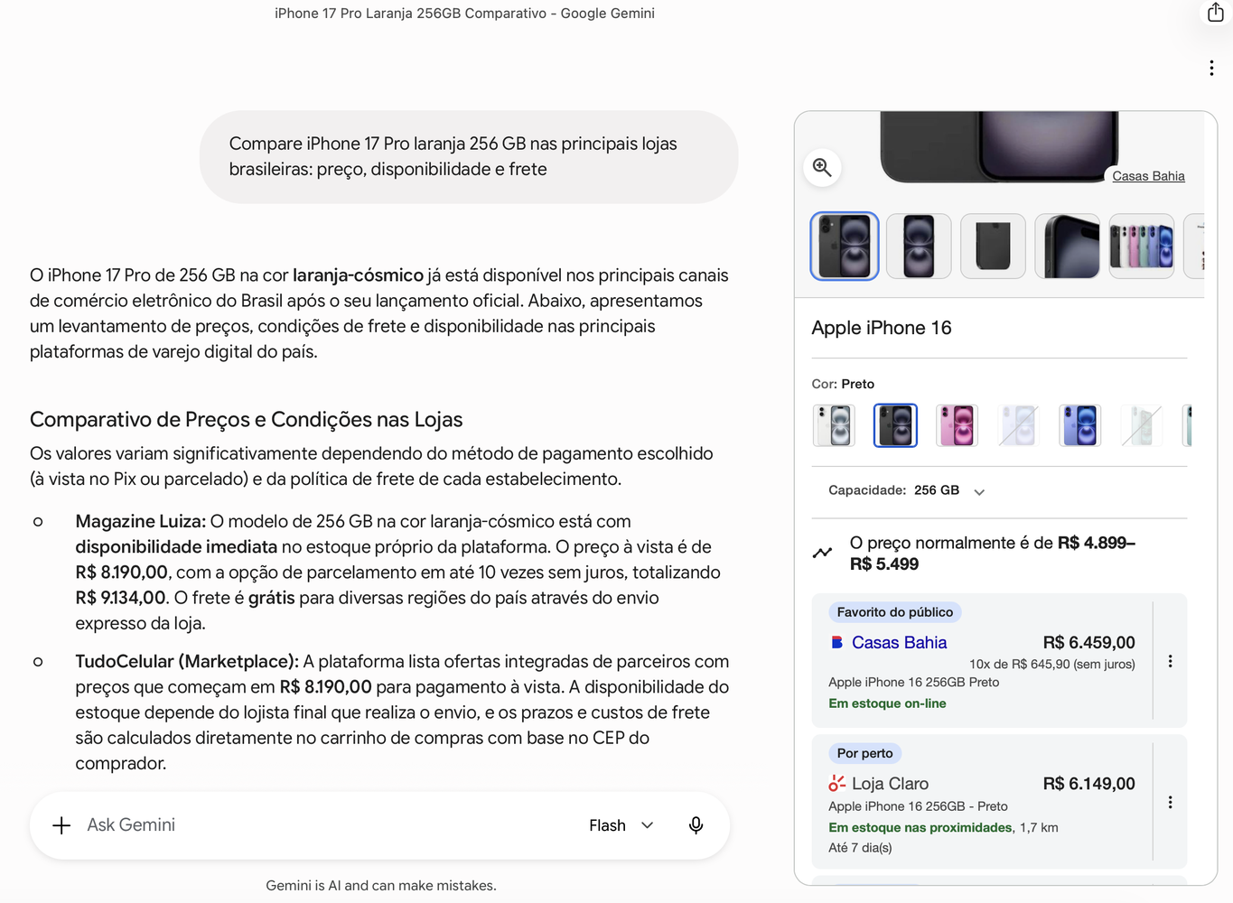
First let’s remember that I’m running my Pipeline on GCP. This pipeline is responsible for collecting data from product urls: content + schema, pagespeed and crux, all these scripts run 3x per day except crux because it’s not necessary. Once each 28 days is good enough to run it. Let’s start analyzing the results, remember I’m doing it for my MBA at USP 🙂. I collected data for 21 days so far and remember I’m extracting data from 7 skus from 15 different stores divided between electronics and skincare.
For this article obviously I’m not showing all my information ok? And just for the matter of fact all this data that I’m going to show is public data - I swear - you can verify all this by yourself. Let’s start with what blocked my crawler. Just a little reminder: I explained in my last article, my pipeline uses static HTML extraction, no JavaScript rendering, no browser fingerprint. If my scraper gets a 403, a direct agent probably does too.
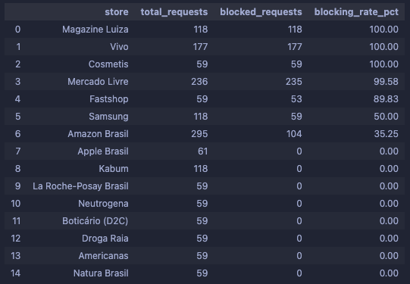
Woow Magazine Luiza what happened here? Well if you look at first image Magalu appears as the recommended store in the chat but, remember, it appears at the position #40 in the Gemini Shopping Bar. Ah, just forget to mention I have 7 skus but the same sku is requested in several stores and the same store has more than 1 sku in more than one case. But Magalu what happens.
We can infer, using wappalyzer, that Magalu has two two overlapping protective layers - Security and Akamai - maybe Akamai Bot Manager (CDN/WAF). Securiti has a specific module to bot detect e consent enforcement. Then we can infer that the block is intentionally, deeper and based on an architectural decision. They invested really hard to block crawlers and this is a very good decision in a country where fraud rate is high. But the same invisibility that I got with my humble crawler could explain why Magalu appears in the #40 positions in Gemini Shopping Bar?
The answer is: probably yes. But to understand why, we need to talk about how LLMs actually split their memory. You probably know what RAG is, so let’s go to the next point. What matters here is the tension between the two memories: what the model learned during training (parametric) and what it retrieves in real time (non-parametric). They don't always agree - and that disagreement is exactly what we're seeing with Magalu.
Google is the sir and owner of search - ads - shopping right? Ads and shopping feeds the gemini shopping bar. Magalu appears in first place in Google Shopping but #40 in Gemini Shopping Bar.
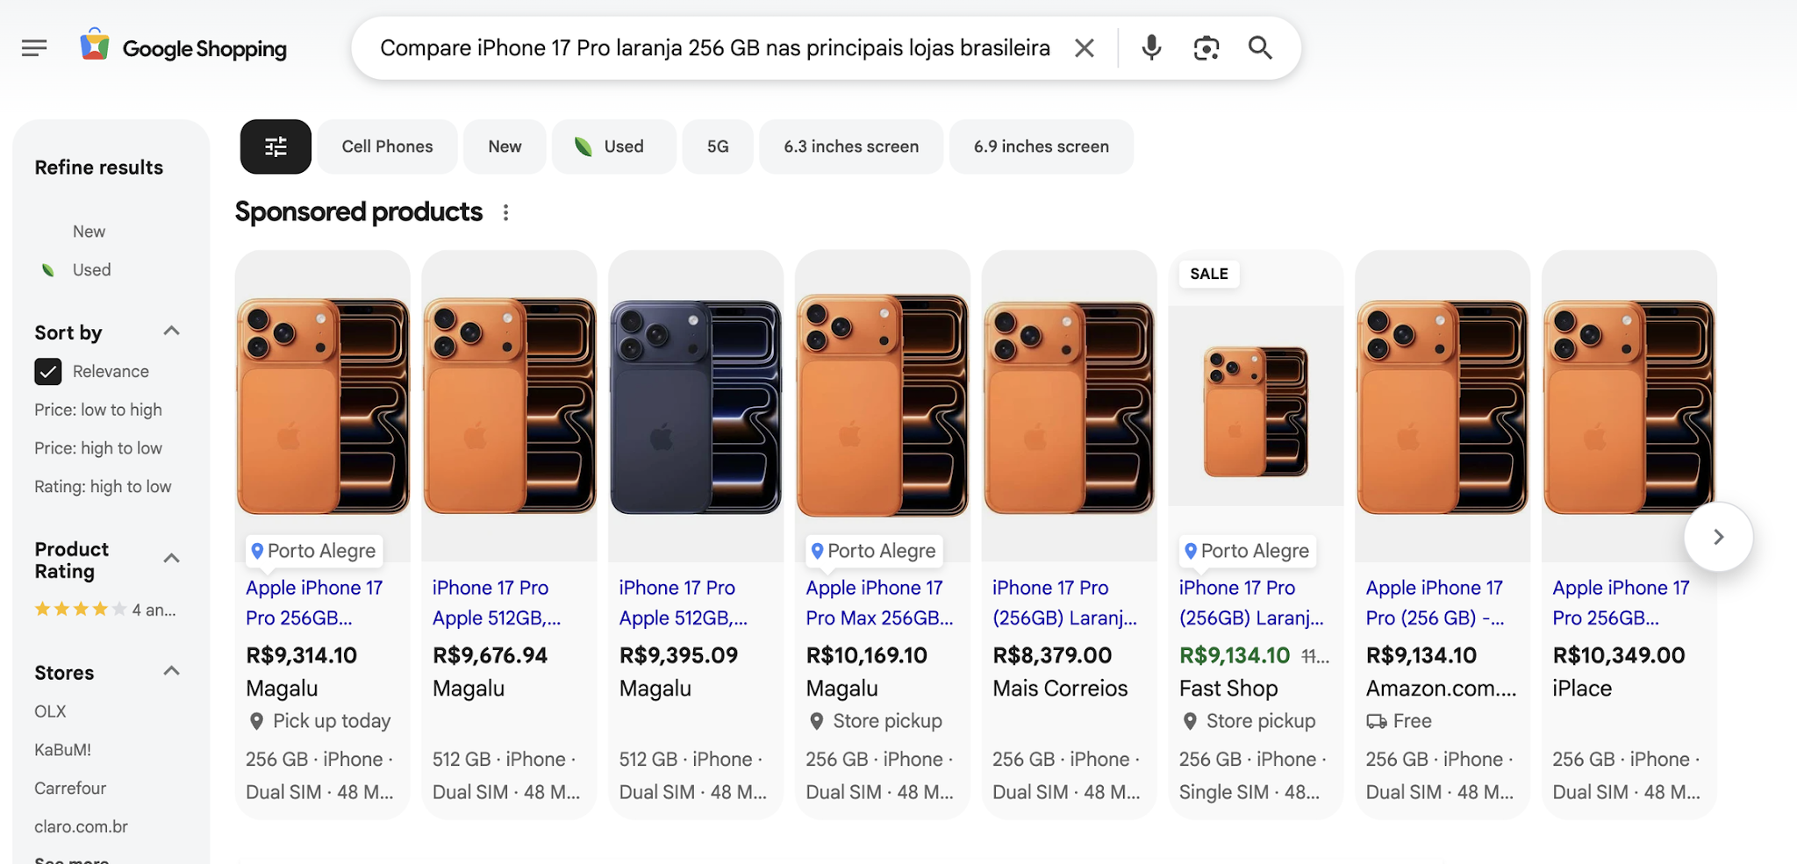
The parametric memory knows that Magalu is a giant store in Brazil and this parametric memory uses grounding to enrich the results. Magalu is amazing with SEO and with autorithy, maybe Hannibal Lecter searching for his mask could find it in Magalu . But the non-parametric memory uses the Google Shopping Graph API or the Merchant Center structured data. And voila our two brains are on the same platform.
The Gemini Shopping Bar is a deterministic environment if the GoogleStoreBot is blocked for Akamai, for example, when it is trying to validate the product’s price in realtime in the PDP the offers ‘falls’ in the Preemptive Item Disapproval.
We saw that Magalu has a strong anti-bot protection and let’s infer that the GoogleStoreBot tried to do the crawler looking for price and stock and got a block. But is blocked GoogleStoreBot possible? I don’t know really, is a theory but yesterday (06/24) I got this results to Magalu:
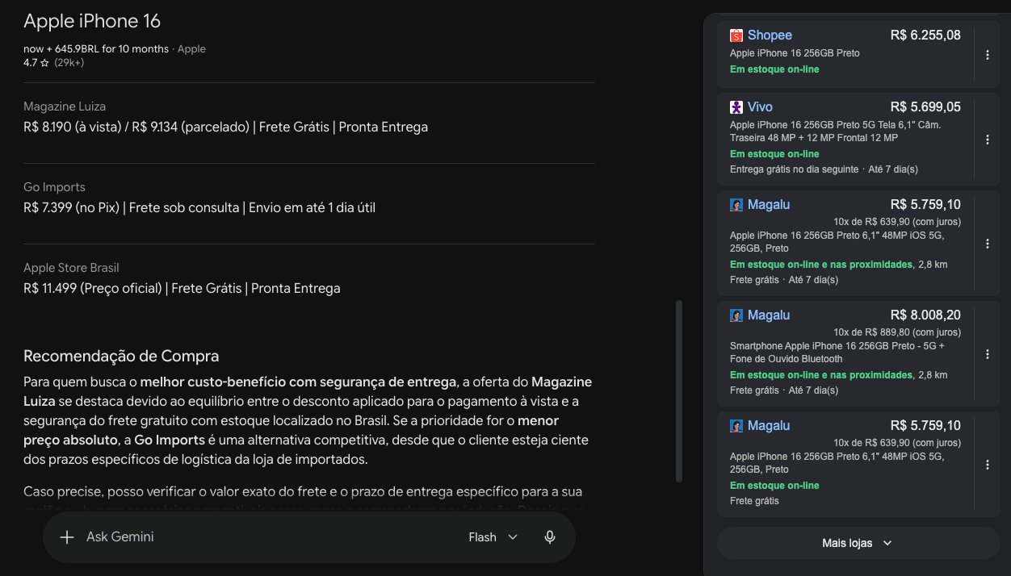
Magazine Luiza appears three times past position #20: twice as the same product with the same price but different delivery information, and once as a bundle incorrectly grouped with the standalone device. The same product, ingested at different moments, produces three inconsistent entries a feed that Google cannot reliably validate.
This is not a Magalu-specific bug. Multiple stores show duplicated entries in the Shopping Graph. The difference is that stores with open access produce consistent duplicates, same data, same state. Magalu's duplicates tell a different story: same product, same price, different delivery data. A feed being read at different moments, never fully validated.

Six Magazine Luiza entries for the same query. Two products, three snapshots each. This is not a bug, this is what a partially validated feed looks like inside the Shopping Graph.
We are seeing all the discussion about SEO/GEO in the linkedin feed, my two cents of opinion is that: GEO/AEO exposed the silos between e-commerces. The security teams reinforce the WAF; the frontend team is focusing on client-side rendering killing the crux with high-latency, and the SEO team creates a marvellous schema.org that the agents are never going to read because they were blocked in the door. When we cross-reference the data from the pipeline, these silos become empirically visible. We can categorize this into two distinct phenomena. First, the "WAF Wall": stores like Magazine Luiza and Vivo presented a 100% block rate for static requests in my dataset. They are structurally closed to simple agents. Second, we have what we could call the "CSR Illusion": stores that left the door open (0% block rate) but delivered 0% of their schema.org markup to the static crawler. The SEO team did their job perfectly, but because the schema is likely injected via Client-Side Rendering (JavaScript), the static agent still sees a blank skeleton.
And just to give a little taste of the performance side-without diving too deep into the metrics- when we look at the CrUX and PageSpeed data, we can see that complex architectures sometimes come with a cost. For example, in our dataset, Vivo presented a mobile PageSpeed score of 9.1 and a CrUX Mobile LCP of over 6 seconds. This suggests that heavy security or complex rendering strategies can occasionally impact not just the agent's ability to parse the site, but also the overall user experience. Who is responsible for that? Who is responsible for the continuous loss of revenue when the AI started to grow on this? E-commerce needs a unified product engineering approach.
Historically, enforcing severe firewall (WAF) or CDN rules to block crawlers generated a manageable corporate friction: your e-commerce bled a few organic positions on the SERP, but the Growth team compensated for the invisibility by injecting massive budgets into Ad campaigns. That playbook is broken. In the dynamics of Agentic Commerce, RAG-based retrieval systems depend on the real-time ingestion of deterministic data to formulate factual answers. The logs from my GCP extraction pipeline expose exactly this schism in the Brazilian market: while Magazine Luiza presents a 100% block rate for static requests, competitors like Kabum operate with a 0% block rate.
The operational outcome of this infrastructure decision? The autonomous agent can cleanly parse Kabum's page, retrieve the technical attributes via Schema, and assemble the comparison shelf recommending the store. The consumer makes the purchasing decision directly within the generative interface, resolving their intent without ever clicking on a traditional blue link. Today, a blind security policy in favor of blocking bots doesn't just tank your ranking; it erases you from mathematical existence in the era of Zero-Click traffic.
Next time I'll bring the CrUX and PageSpeed data into this. Because what I'm seeing on the performance side is just as interesting and just as uncomfortable and my research started with Crux Data.

